**California Hospital Inpatient Mortality Rates and Quality Ratings**

**Thao Nguyen**

**06/2024**

**Project Overview:** This project analyzes California hospital inpatient mortality rates and quality ratings across various medical conditions and procedures from 2016 to 2022. The dataset includes risk-adjusted mortality rates, quality ratings, and the number of deaths and cases for six medical conditions (Acute Stroke, Acute Myocardial Infarction, Heart Failure, Gastrointestinal Hemorrhage, Hip Fracture, and Pneumonia) and five procedures (Abdominal Aortic Aneurysm Repair – Open and Endovascular, Carotid Endarterectomy, Pancreatic Resection, Percutaneous Coronary Intervention).

**Data Source and Methodology:** The data was sourced from *HealthData.gov* and comprises 639,194 records with 12 attributes detailing the year, county, hospital information, ratings, number of conditions/procedures, and deaths. The mortality indices (IMIs) for 2022 were generated using AHRQ Version 2023, while earlier years used previous versions. Due to methodological changes, trend comparisons over time should be approached with caution. The analysis primarily focuses on inpatient data, excluding outpatient settings.

**Analytical Tools:** The project utilized Excel for data manipulation, employing aggregate functions, Pivot Tables, and Pivot Charts for in-depth analysis.

**Key Findings:**

1. **Overall Trends:**
   * Both conditions/procedures and death cases showed a significant decline from 2020 to 2022.
   * A stable increase in cases and deaths from 2016 to 2020 was followed by a notable drop in 2021, suggesting improvements in healthcare quality.
2. **Condition-Specific Insights:**
   * Heart failure and acute stroke were the most prevalent conditions throughout the observed years.
   * Pneumonia cases surged during the peak of the COVID-19 pandemic in 2020, aligning with a decrease in heart failure cases.
   * Acute stroke cases remained stable until 2020, then significantly dropped in 2021 and 2022.
3. **Mortality Rates by County:**
   * Los Angeles County exhibited the highest mortality rates, fluctuating between 80,000 and 100,000 cases from 2016 to 2020, before decreasing to 50,000 in the last two years.
   * Orange County had the second-highest mortality rate, though significantly lower, ranging from 1,000 to 2,000 cases.
4. **Fatal Conditions:**
   * Acute Stroke Hemorrhagic and Acute Stroke Subarachnoid were the most fatal conditions, with an average mortality rate of 23%.
   * Heart failure, despite being common, did not significantly contribute to mortality rates.
5. **Hospital Performance:**
   * Centinela Hospital Medical Center consistently received the highest ratings ("Better") during the investigation period.
   * Mercy Medical Center Redding and Antelope Valley Hospital were frequently rated the lowest ("Worse"), with 43 such ratings each.

**Detailed Analysis:**

1. **Overall Trend of Conditions/Procedures vs. Death:**

Using a Pivot Table to summarize the Year, Sum of Conditions/Procedures, and Sum of Death, the trends for both variables were very similar, revealing a stable increase from 2016 to 2020. A significant drop from 2020 to 2021, followed by an increase in 2022, implies improvements in California healthcare quality post-2020.

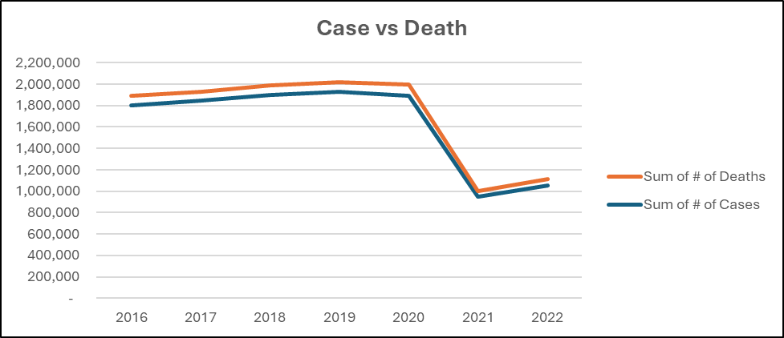

1. **Conditions/Procedures Breakdown by Year:**

Before 2020, heart failure was the most common health condition in California, with approximately 100,000 cases. In 2020, during the peak of COVID-19, Pneumonia became the second most common health condition, with heart failure cases decreasing to levels similar to Pneumonia. Acute stroke cases remained stable around 120,000 from 2016 to 2020, then dropped to approximately 60,000 in 2021 and 2022.

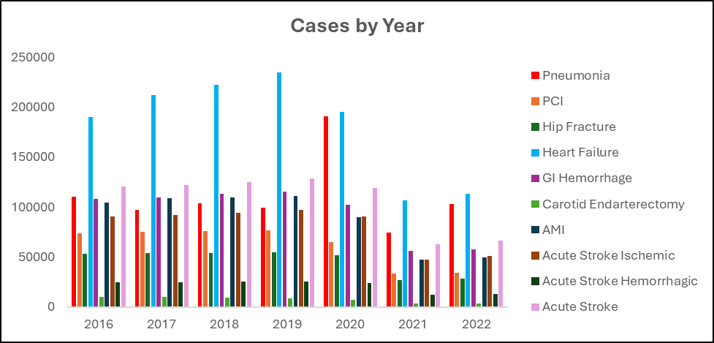

1. **Mortality Rates:**

Los Angeles exhibited dramatic mortality rates from 2016 to 2020, fluctuating between 80,000 to 100,000, then dropping to 50,000 in the last two years. Orange County ranked second, but with significantly lower death rates, fluctuating around 1,000 to 2,000 cases.

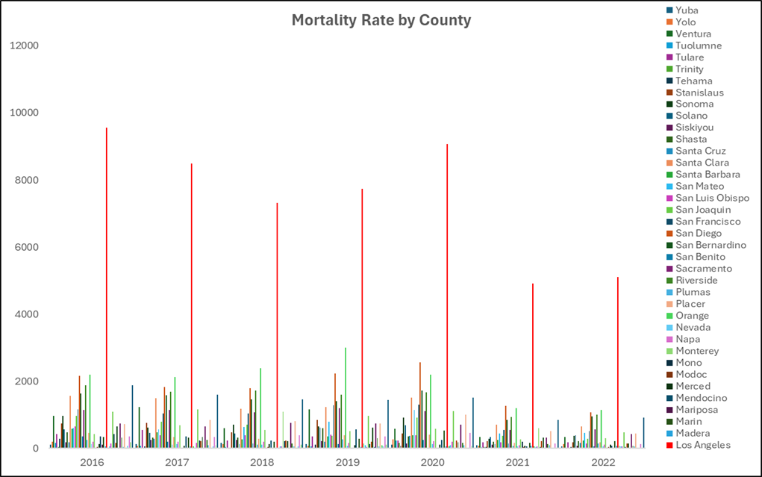

Despite heart failure being the most common condition during the observation period, the highest mortality rates were primarily due to Acute Stroke and Pneumonia.

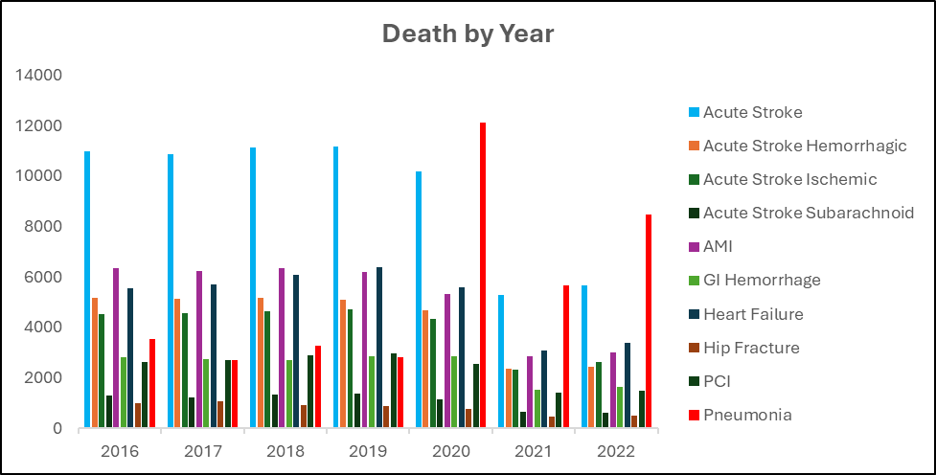

The death rate from heart failure was not as significant. Specifically, Acute Stroke Hemorrhagic and Acute Stroke Subarachnoid have been the most fatal conditions in California since 2016, with an average mortality rate of around 23% per case.

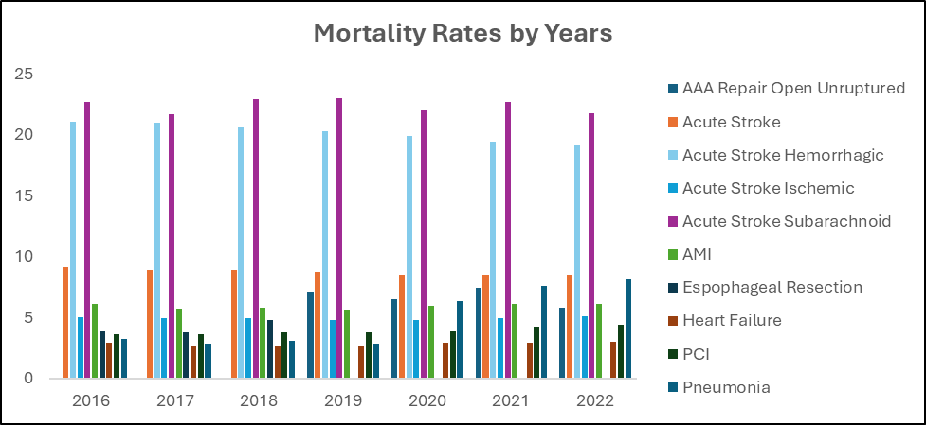

1. **More Cases Leading to More Deaths?** Analyzing the relationship between the number of conditions/procedures and deaths using a Scatter Plot, no particular trend was found. This indicates that more cases did not necessarily lead to more deaths, suggesting California hospitals managed the increased case load effectively.

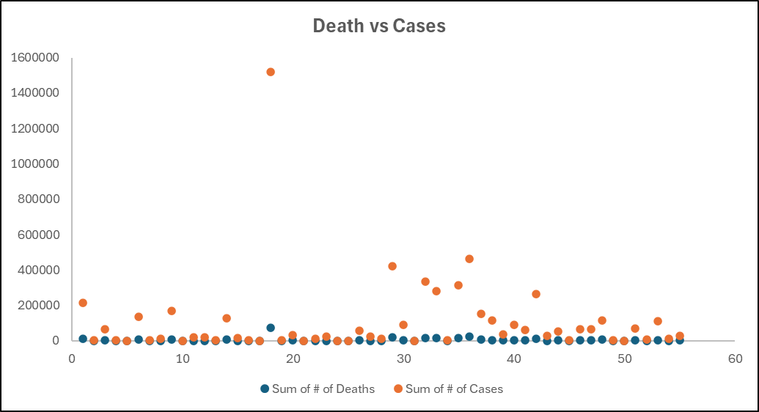

1. **Hospital Ratings:** The dataset includes four rating categories: Better, As Expected, None, and Worse. Generally, Californian hospitals were rated “As Expected” from 2016 to 2022, though this rating category decreased by almost half in 2021 and 2022 compared to previous years.

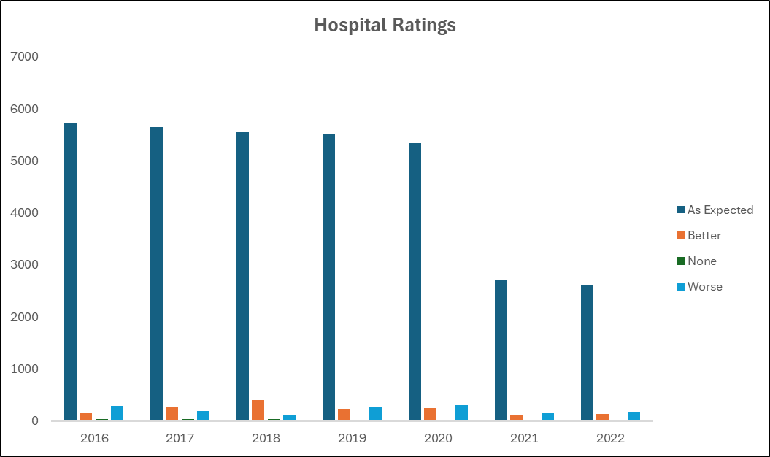

**Bonus Analysis:**

* **Top Hospitals:** Filtering the top ten hospitals with the highest "Better" ratings revealed that Centinela Hospital Medical Center was consistently the best-performing hospital.

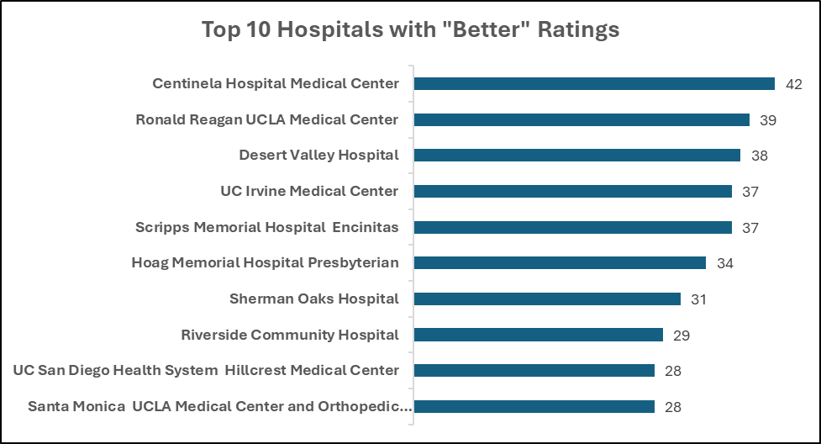

* **Lowest Rated Hospitals:** Similarly, analyzing the hospitals with the most "Worse" ratings identified Mercy Medical Center Redding and Antelope Valley Hospital as the worst-performing hospitals, each receiving 43 "Worse" ratings.

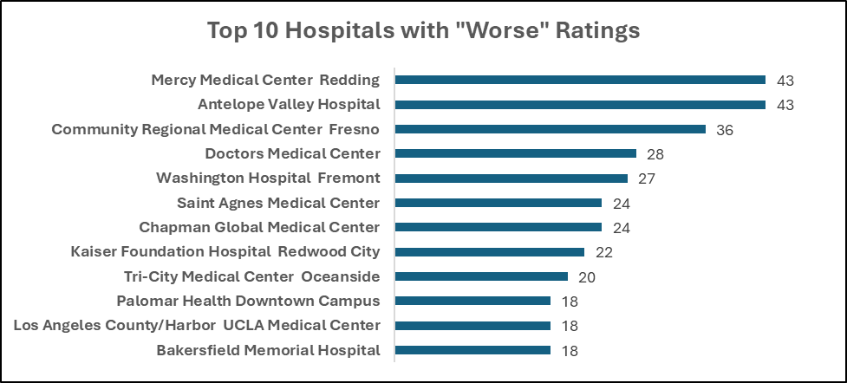

**Analysis Conclusions:** The data indicates that California hospitals have effectively reduced case numbers and mortality rates since 2020. Most deaths were due to acute conditions like Stroke and Pneumonia rather than chronic conditions, highlighting the hospitals' competency in managing treatable health issues. Overall, California hospitals have met inpatient care expectations, reflected in the generally high-quality ratings.

**Future Outlook:** Continuous data for 2023 and 2024 would be valuable to evaluate whether the improvements in mortality rates and hospital performance are sustained. Future analyses should focus on the long-term impact of these trends and the effectiveness of interventions implemented during the observed period.

**References:**

Dataset: <https://healthdata.gov/State/California-Hospital-Inpatient-Mortality-Rates-and-/rzs9-tpdk/about_data>